12/6/2014

Samuel Williamson

Bournemouth University

Trigonometry Calculator report

CGG Assignment 1

Contents

Introduction 2

Requirement Specification 3

Research and mathematical solutions 4

Program descriptions and system diagram 5

Project progress and problems encountered 9

Log 10

User testing 11

Conclusion 12

# Introduction

The problem provided asked for the following:

“If you know some information about a right-angled triangle (such as the length of a side and an angle), you can use trigonometry to calculate the missing information. For this assignment option, write a text based program which asks the user for the information they know about a triangle, calculates the information they don’t know and displays this to the user. This final information should be the length of all sides and all angles.”

Summarising this into small chunks gave me three main requirements:

* Write a text based program which asks the user for the information they know about a triangle
* Calculate the information the user doesn’t know
* Display all relevant information about the triangle solved

However, the problem also suggested possible features to include to make the program a better user experience. These included:

* Allow it to also work with triangles that don’t have a right-angle
* Allow it to calculate all angles when only given all lengths, or when given one side and two angles
* Output the area of the triangle
* Use some ASCII art on the console to show a triangle visually, to help the user with entering their values
* Use a graphical user interface system for user input and output of results
* Draw a scale graphic of the triangle that the user has described
* Add a graphical-calculator feature to graph the basic trigonometry functions and then extend this to allow any arbitrary function of x and y that the user inputs

The final three points needed the use of a graphics library to complete. I therefore believed that these requirements were out of my current programming ability to complete them without too much time being consumed in learning this complex skill. I therefore did not include these in my final requirement specification.

# Requirement Specification

|  |  |  |
| --- | --- | --- |
| Requirement No. | Requirement | Justification |
| 1. | Must be a text based program. | It was the first requirement understood in the brief. |
| 2. | Must accept all of the user’s knowledge concerning the problem triangle. | The program should flex to meet the users requirement not vice versa. |
| 3. | Calculate the triangles missing information. | The program will require this to be of any use. |
| 4. | Display relevant information for the solved triangle. | The program should make it ease of access for end user. |
| 5. | It should be able to solve non right angled triangles. | This will be an added function for the end user. |
| 6. | It should calculate all angles when only given all lengths, or when given one side and two angles. | This will be an added function for the end user. |
| 7. | It should output the area of the triangle. | More relevant information for the end user. |
| 8. | The program should make use of ASCII art in order to help the user enter information. | This will help with making the user experience more easy and fluid. |
| 9. | The program should make use of ASCII art in order to help the user understand the calculation and answers for the information of the triangle. | This will help the user with understanding the results. |

# Research and mathematical solutions

|  |  |  |  |  |  |
| --- | --- | --- | --- | --- | --- |
| ID | Mathematical Problem | Scenario | Summary | Formulas needed | Reference |
| 1 | Trigonometry / Pythagoras | User has 2 angles and 1 side not between | Use the three angles add to 180° to find the other angle. Then The Law of Sines to find each of the other two sides. | a/sin A = c/sin C  b/sin B = c/sin C | http://www.mathsisfun.com/algebra/trig-solving-aas-triangles.html |
| 2 | Trigonometry / Pythagoras | User has 2 angles and 1 side between | Find the third angle using the three angles add to 180°. Then use The Law of Sines to find each of the other two sides. | a/sinA = c/sin C  b/sinB = c/sin C | http://www.mathsisfun.com/algebra/trig-solving-asa-triangles.html |
| 3 | Trigonometry / Pythagoras | User has 2 Sides and 1 Angle between | Use The Law of Cosines first to calculate the third side of the triangle. Then use The Law of Sines to find the smaller of the other two angles. Finally use the three angles add to 180° to find the last angle. | a2 = b2 + c2 − 2bc cosA  sin B / b = sin A / a | http://www.mathsisfun.com/algebra/trig-solving-sas-triangles.html |
| 4 | Trigonometry / Pythagoras | User has 2 Sides and 1 Angle not between | Use The Law of Sines first to calculate one of the other two angles. Then use the three angles add to 180° to find the other angle. Finally use The Law of Sines again to find the unknown side. | sin(C)/c = sin(B)/b  a/sin(A) = b/sin(B) | http://www.mathsisfun.com/algebra/trig-solving-ssa-triangles.html |
| 5 | Trigonometry / Pythagoras | User has 3 sides | Use The Law of Cosines first to calculate one of the angles. Then use The Law of Cosines again to find another angle. Finally use angles of a triangle add to 180° to find the last angle. | cos A = (b2 + c2 − a2) / 2bc  cos B = (c2 + a2 − b2)/2ca | http://www.mathsisfun.com/algebra/trig-solving-sss-triangles.html |
| 6 | Pythagoras | User has two sides | Use angles of a triangle add to 180° to find the last angle. | a² = b² + c² | http://www.mathsisfun.com/pythagoras.html |
| 7 | Area | User has all sides | Uses two smallest sides to figure out the area of the triangle | Area = 1/2B*H | http://www.mathsisfun.com/algebra/trig-area-triangle-without-right-angle.html |

For my calculator, I knew I would have to use both Trigonometry and Pythagoras theorem to solve the triangle. Trigonometry is a methodology for finding some unknown elements of a triangle. This done using and rearranging formulas using the terms Sine, Cosine and the Tangent. Trigonometry is used to figure out sides from angles and angle from sides. Pythagoras uses the power of deduction to figure out the 3rd side, when the user already has 2 sides using the equation a² = b² + c². Both methods would be used in my calculator.

# Program descriptions and system diagram

My initial thought was to create a large menu based system with dozens of options for every possible case. However, after deliberating the idea, I decided to uses a mix of menus and If statements in the code. This was decided as I felt that too many options could confuse and frustrate the end user. There would be one menu with three of the options relating to the problem solving of the triangle and one other option to quit the application. Therefore all the end user needed to do was select the most appropriate listed option in the menu.

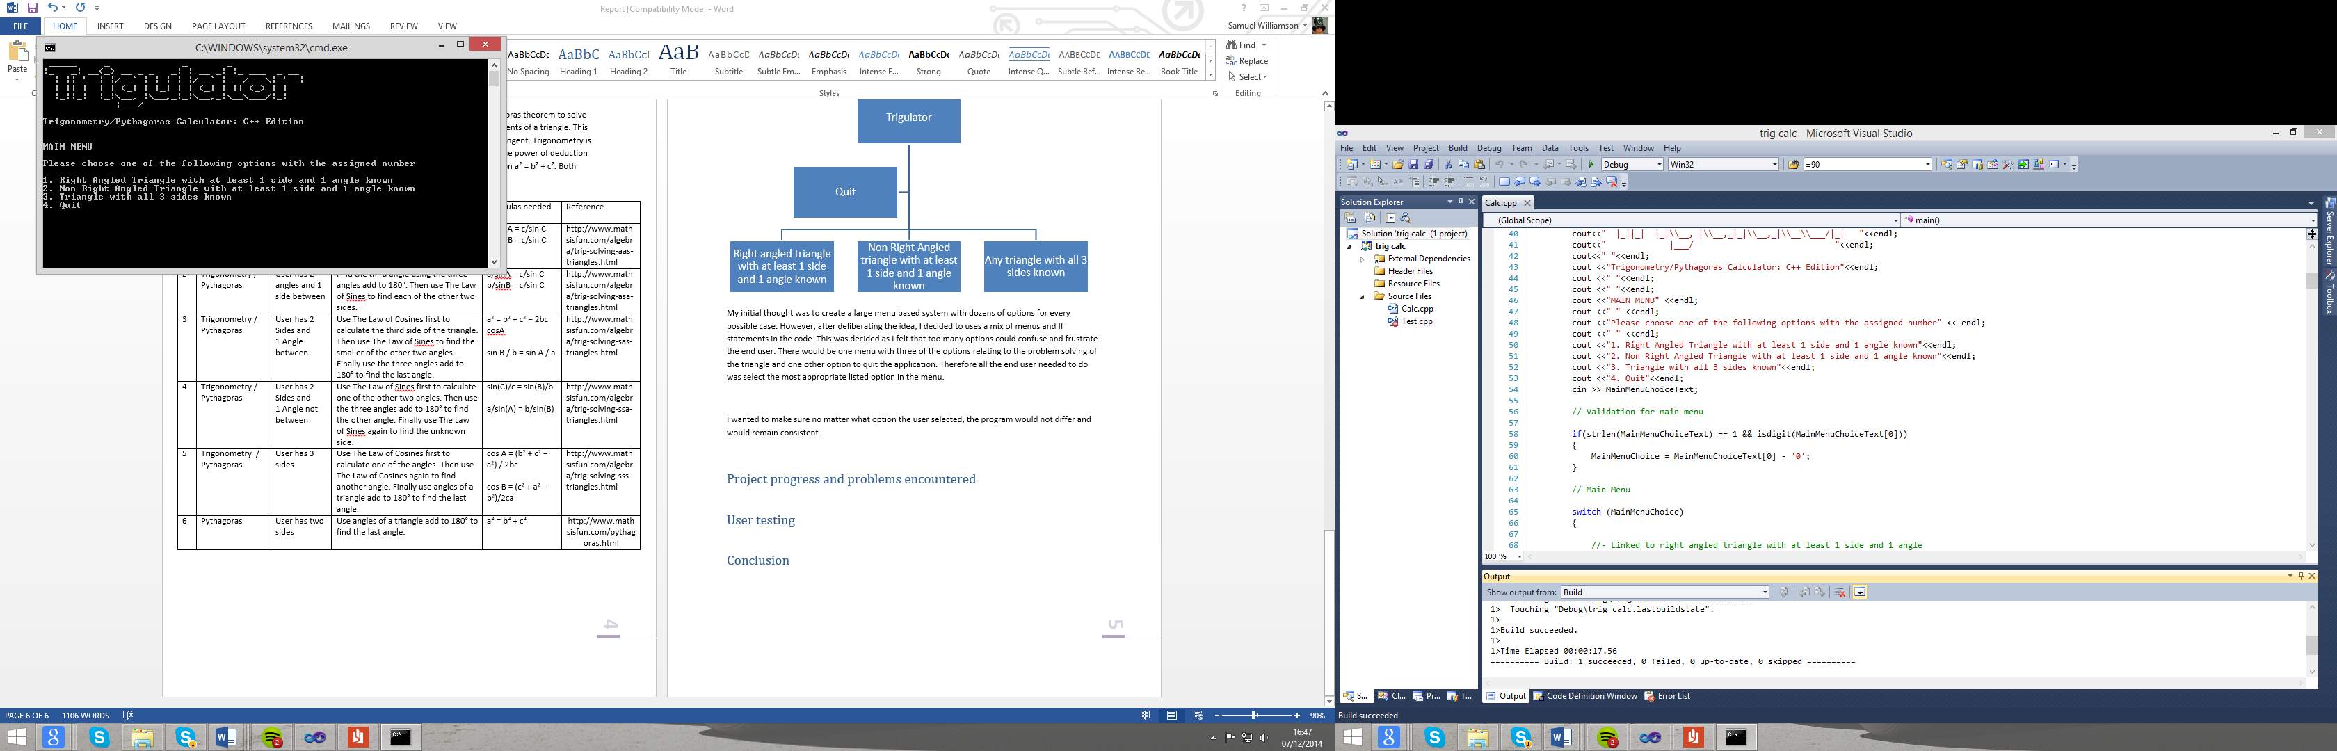

I wanted to make sure no matter what option the user selected, the program would not differ and would remain consistent.

The first thing the user would be greeted with is a diagram of the triangle in order to assist the user with entering and understanding the information entered like shown below.

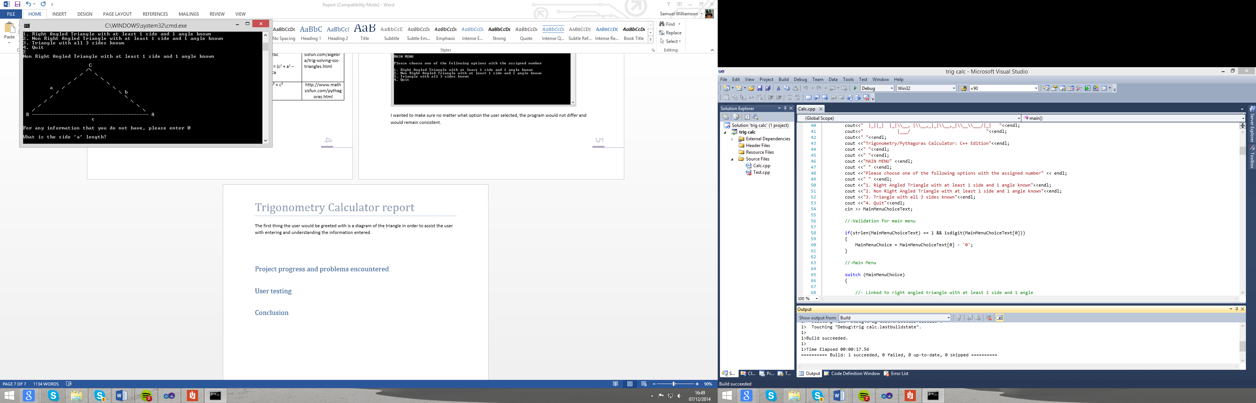

The only menu that doesn’t follow this procedure is for the right angled triangle as it needs to determine if the user knows angle C or angle B. It then uses this information to decide which diagram for the triangle to display as shown below.

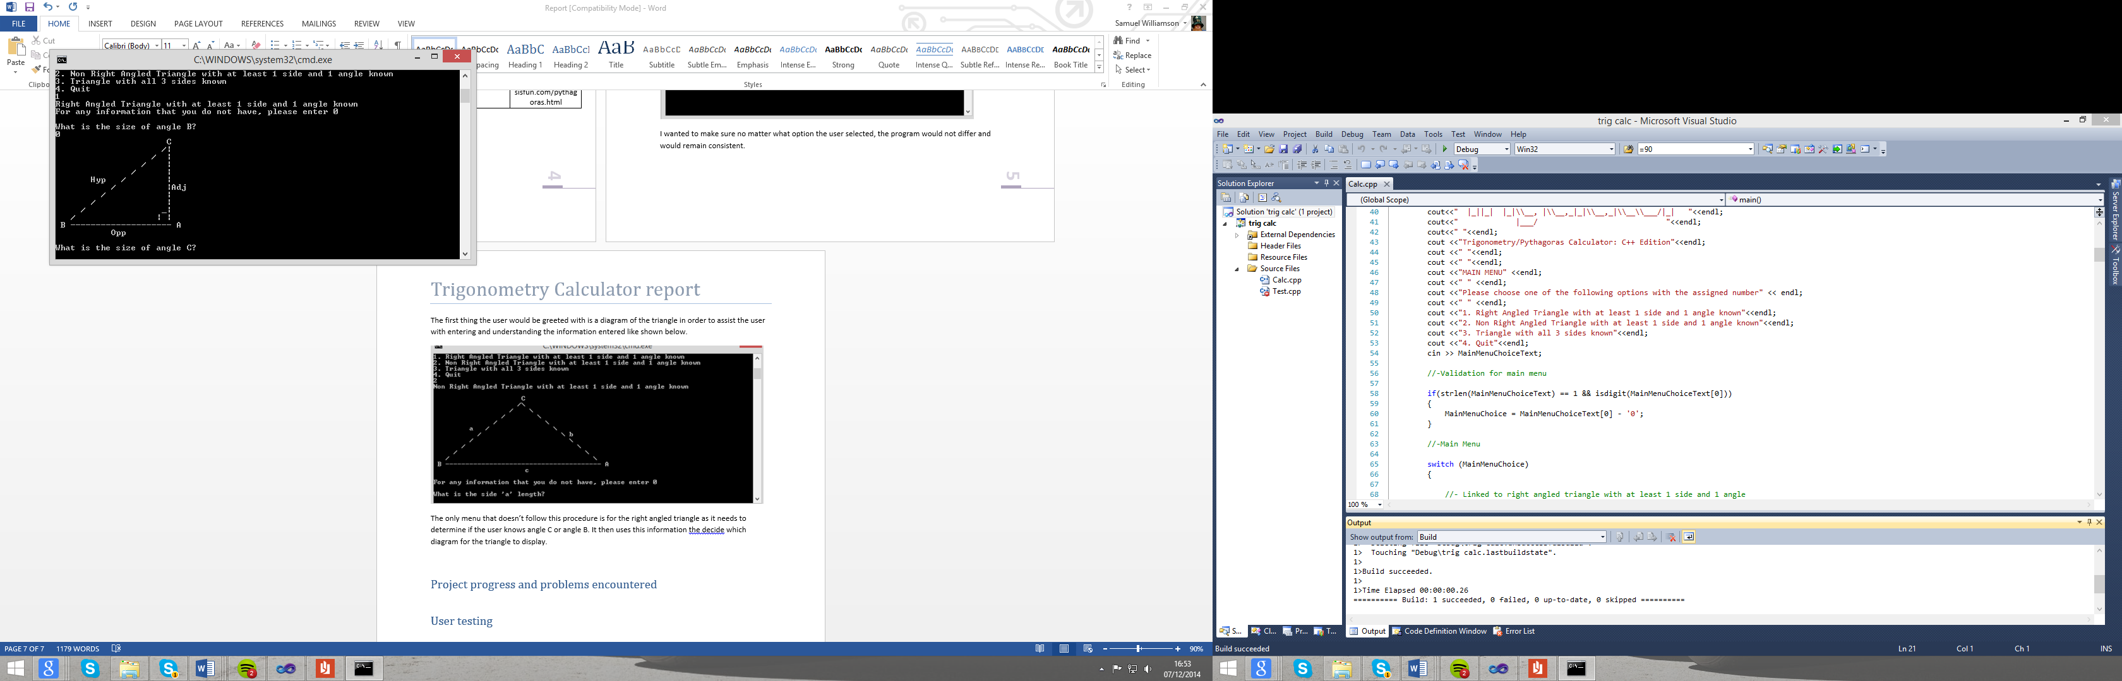

The next stage is to gather the information known by the end user. This is done by asking the user to enter any information that they indeed know. For any information not known, the user is asked to enter a 0.

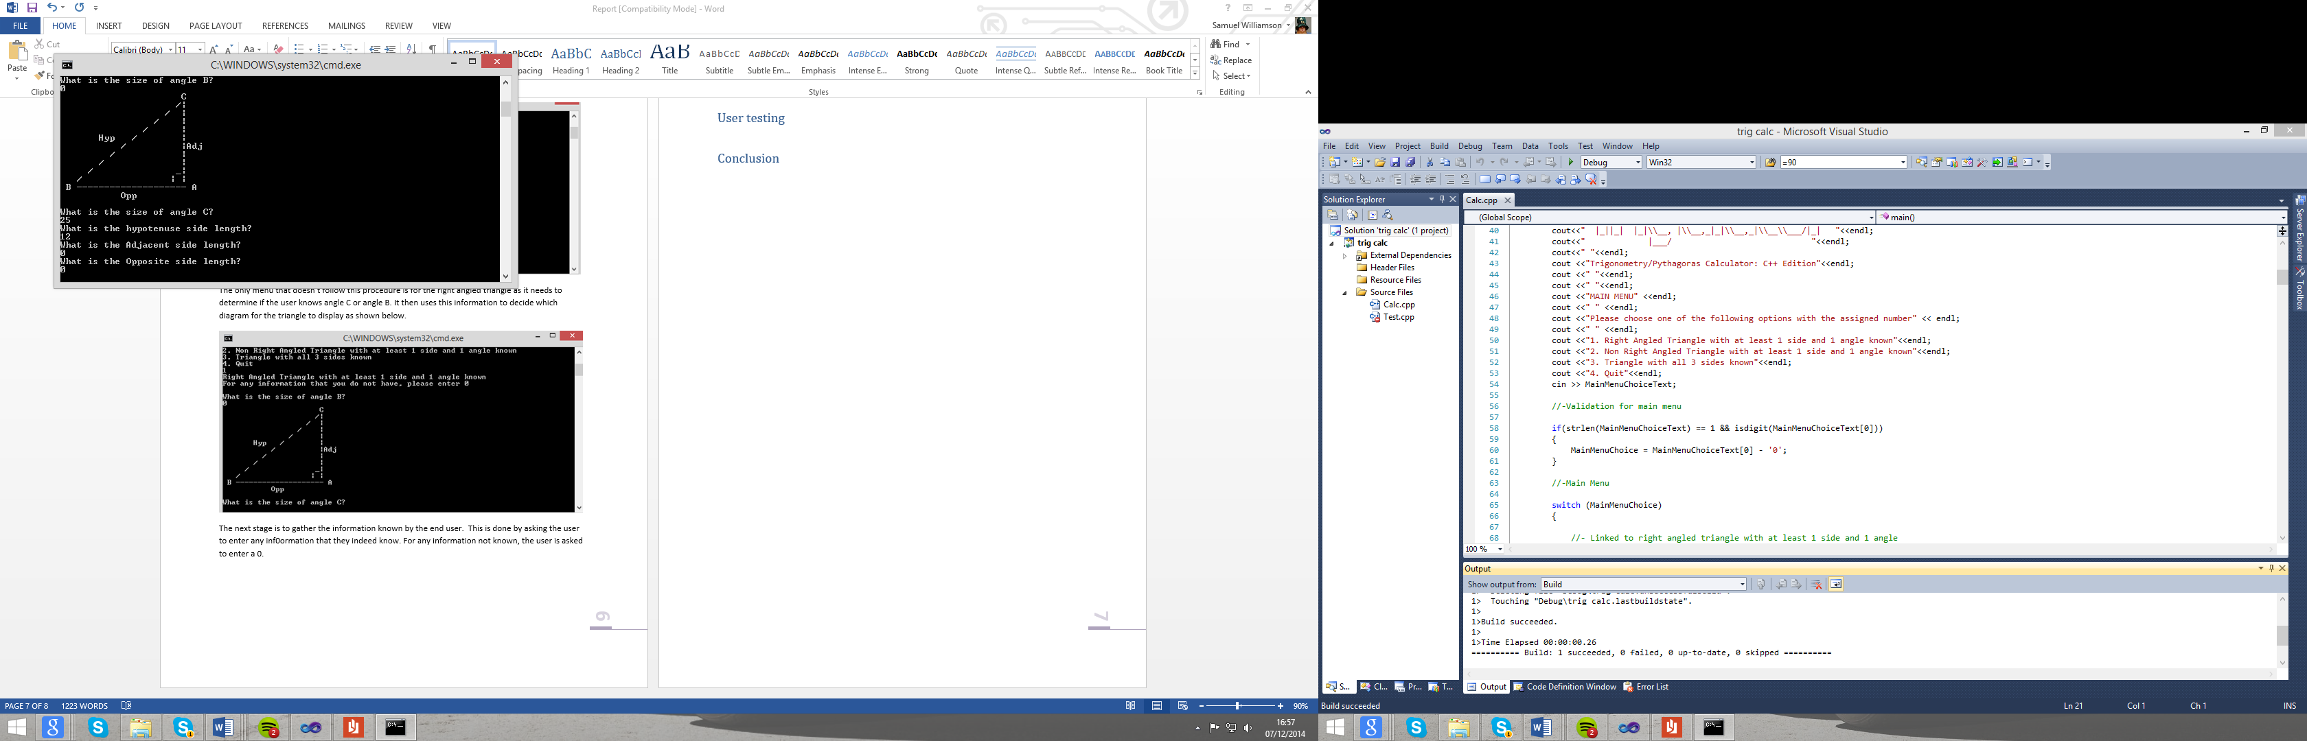

The system then uses a series of ‘If’ statements to figure out what equations to use in order to solve the triangle.

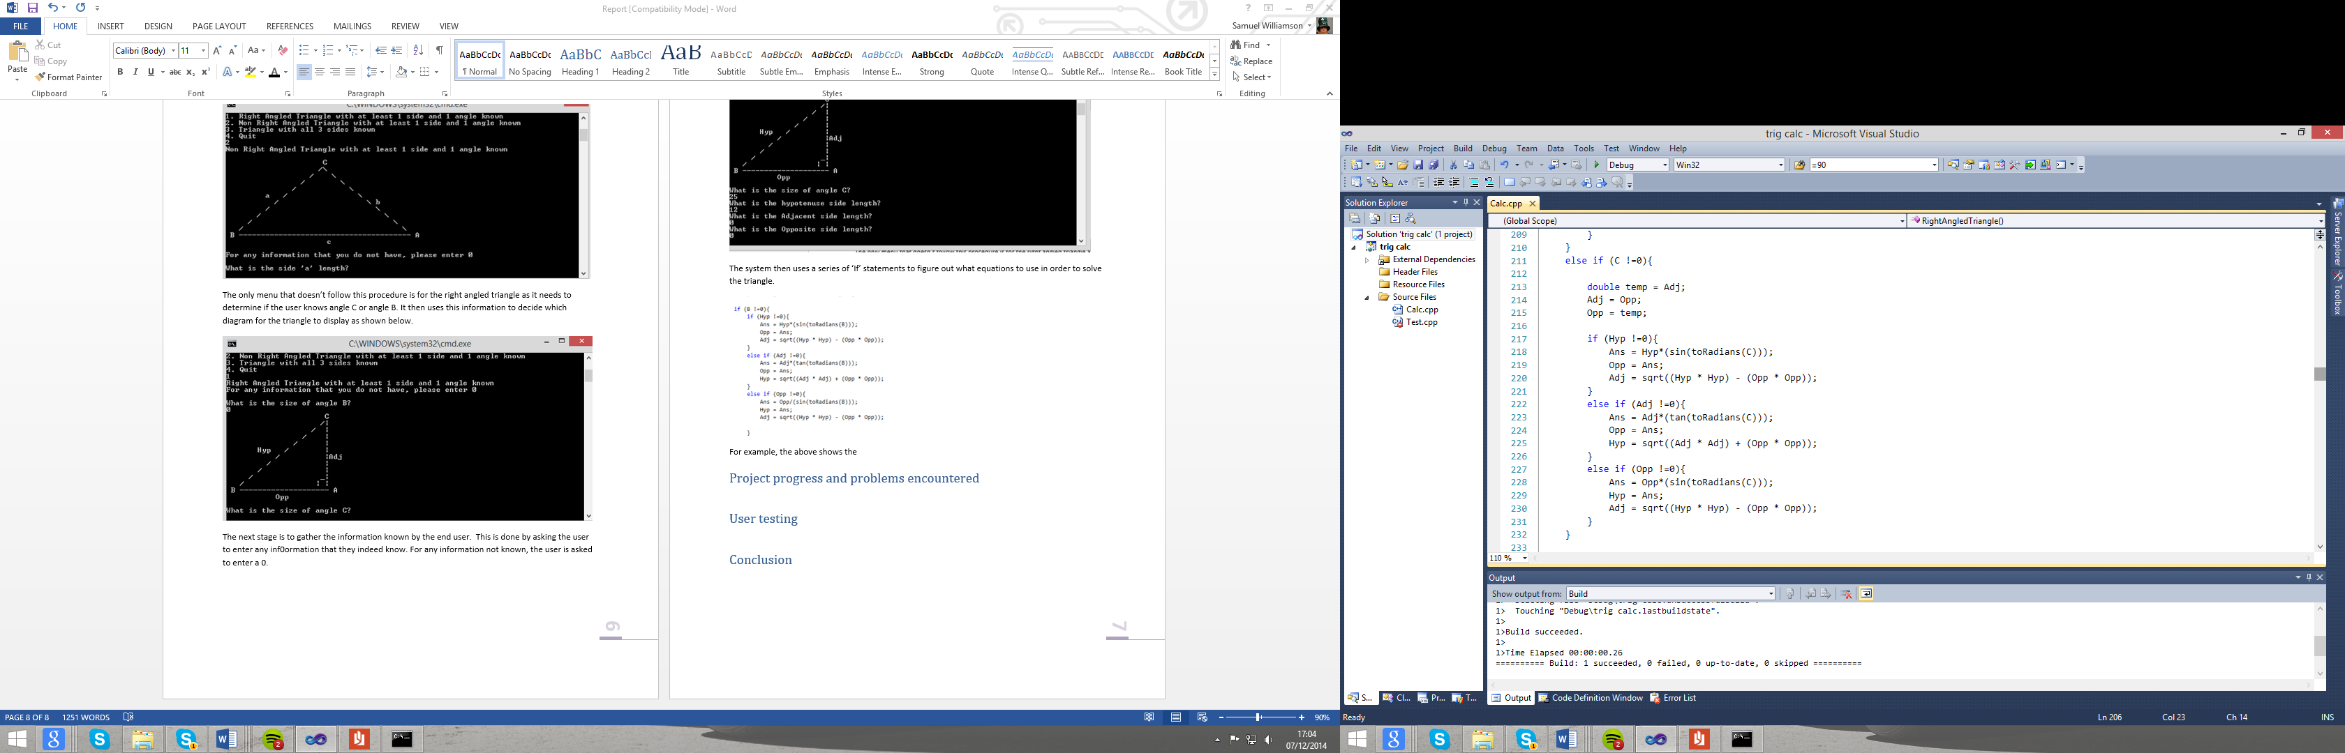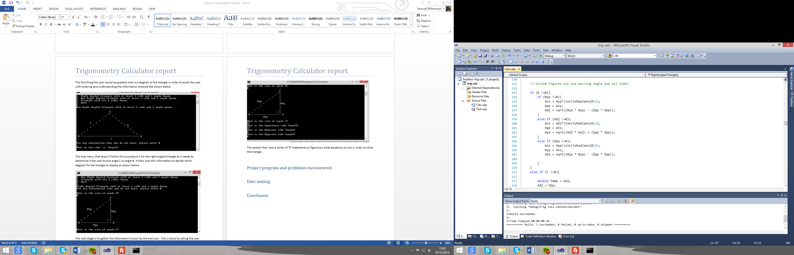

OR

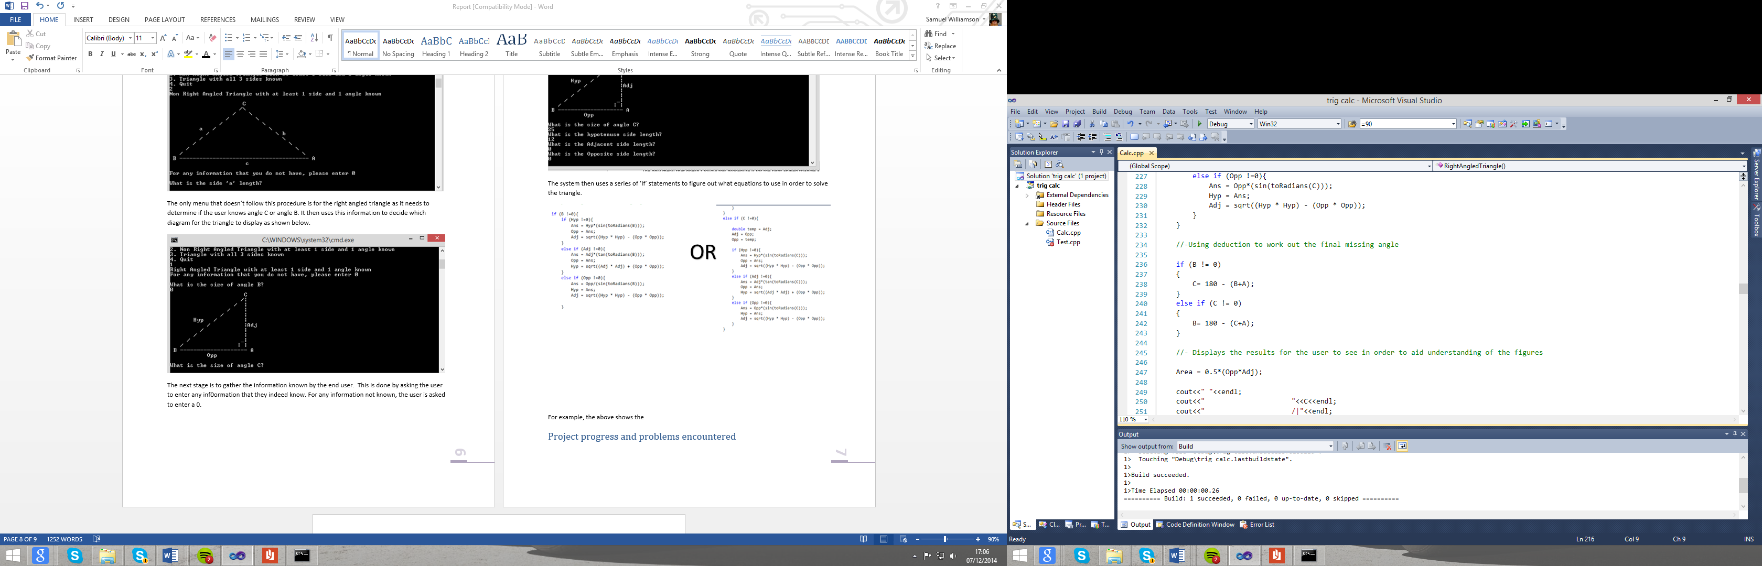

For example, the above shows the calculations and if statement for figuring out the right angled triangle. The system decides on whether the system has angle B or C and figures out the remaining side lengths using Trigonometry. The system then figures out the last remain angle using Pythagoras once again using the decision made earlier as to if the end user has angle B or C.

The final stage of the system is to present the end user with the calculated values with a visual representation and a list view. The system also give the end user an option to return to the menu if they have any more problems to solve.

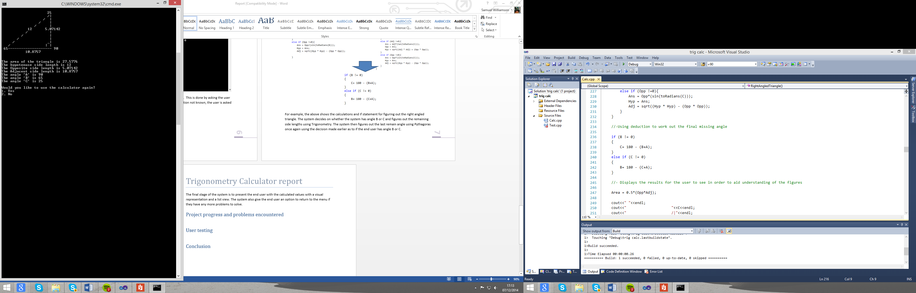

This is the basics layout of how my system works. Obviously, it differs slightly depending on each scenario.

Another function worth mentioning is the area calculation. This is done in two different ways. For the right angled triangle, it is very simple. The area is ½ *(Opposite * Adjacent) as shown below.

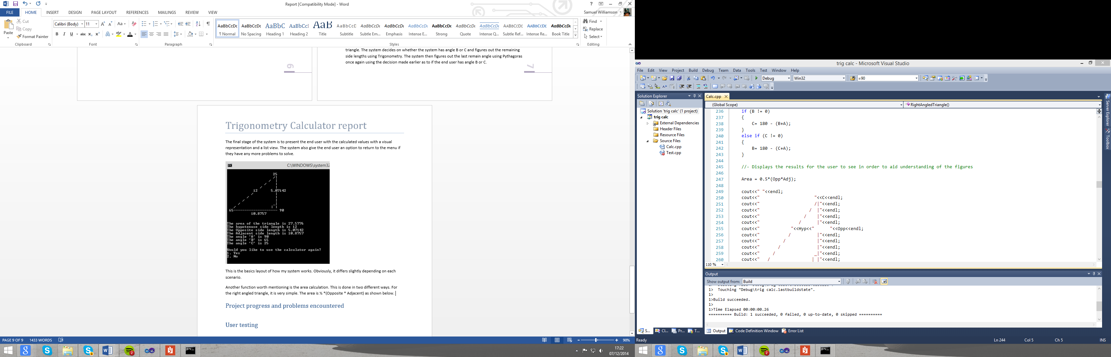

However, there is an extra stage required when working with a normal triangle. The problem is that you first must figure out what the Adjacent and the Opposite side is or another way of putting it is the two smallest sides. Then using the two smallest sides in the area equation. I did this using the code below.

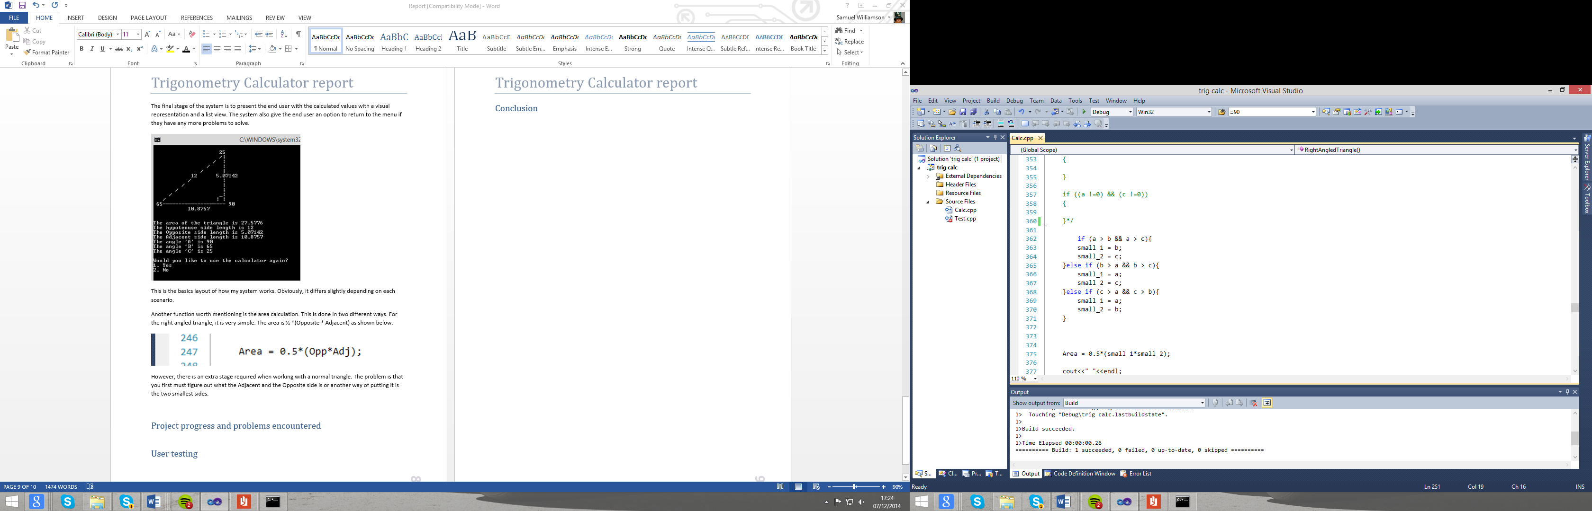

A more in depth view on how the system operates can be found on my system flow chart which can be accessed by clicking [here](code2flow_1f576.pdf).

# Project progress and problems encountered

As for problems, I didn’t encounter any major problems while I was developing the system. Many if not most of my problems actually came from novice coding errors. These included forgetting the end the line, using a capital where there should have been a lower case instead and miss spelling a function. Along with this, there was a few math errors where I used variables in the wrong order or used a capital ‘A’ for a side instead of a small ‘a’.

However, the main problem I encountered was the accuracy of the results I was getting. Initially I was using floats instead of the now used doubles. These were making subtle changes to the calculation results and corrupting the outcome. However, after same trial and error, I found that using doubles as a data type worked much more effectively and resulted in the correct result.

As an outcome of these problems, I am now more aware of possible problems that can occur when coding. However, I am not just more aware I have learnt to deal with them much more professionally by using tools that Visual Studio provides. The main function I found key when it came to diagnosing was the ability to use break points. These allowed me to check how certain variables were inheriting values. This helped diagnose issues much quicker as I learned how to use this tool compared to reading over lines of code and making assumptions. Therefore, my next project will take less time to develop as I will handle problem and errors in a more professional manor.

# Log

|  |  |
| --- | --- |
| Date | Entry |
| 22/11/2014 | I have started by making the calculator function with set values for a right angled triangle. However, I am getting the wrong results so there maybe something wrong the equation as it is only off the true value by 10ths of a value. |
| 25/11/2014 | After much investigation, I have concluded that I should use doubles instead of floats as a data type. Also today, I have managed to allow the system to accept different values from the user. |
| 28/11/2014 | I have created ASCII art to assist the end user when entering values. I have also created ASCII art to help the user understand the values with a diagram at the end. |
| 30/11/2014 | Today I created a function to turn degrees into radians and vice versa. I have also started to put my code into a menu structure using a switch. |
| 1/12/2014 | Today I have started to code for any triangle with 3 sides known. This has involved using harder maths by using the inverses. I have been unable to complete as VS is showing lots of errors! |
| 2/12/2014 | Found the previous errors and corrected them. I have now completed this stage of the build. I have also started a little on the final part of the puzzle. Non Right Angled Triangle with at least 1 side and 1 angle known. |
| 4/12/2014 | I have decided that my menu structure is too messy and I am finding difficult to read. Therefore I have changed the system to now use functions. This is keeping my work much more tidy than before. |
| 5/12/2014 | Tried completing the final function. But am struggling with some of the maths. This part shall be incomplete but have some functionality. |
| 6/12/2014 | I have started my report and have completed up till the program description and diagram. Also tried fixing the semi functioning part of the program but still no luck. |
| 7/12/2014 | Completed the report and once again tried to fix the semi working part of the program. Still no luck. I will leave it included in the program but not all functions will work. |

# User testing

For user testing I will user random numbers to check many aspects of the system. These results will then be compared to the results given on this trusted [website](http://www.mathwarehouse.com/triangle-calculator/online.php):

|  |  |  |  |  |  |
| --- | --- | --- | --- | --- | --- |
| Test ID | Description | Requirement No. | Data to be inputted | Expected outcome | Actual Outcome |
| 1 | Checking to see if the program is text based | 1 | N/A | Yes | Yes |
| 2 | Testing all possible user values can be entered and other | 2,3,4,5,6 | A=45  a=21  c=12 | All data was accepted | All data was accepted, b=0  B=0  C=0,  All data was shown as calculated, but calculation was wrong |
| 3 | Testing all possible user values can be entered and other | 2,3,4,5,6 | a=14  B=33  C=64 | All data was accepted | All data was accepted, A=83  b=8.48  c=9.36,  All data was shown as calculated, but calculation was wrong. |
| 4 | Testing all possible user values can be entered and other | 2,3,4,6,10 | A=90  B=33  c=13 | All data was accepted | All data was accepted,  a=15.50  b=8.44  C=57, |
| 5 | Testing all possible user values can be entered and other | 2,3,4,5,6 | a=14  b=12  c=15 | All data was accepted | All data was accepted, A=61.26  B=48.73  C=70, |
| 6 | Area of the triangle is outputted | 7 | A=45  a=21  c=12 | N/A | Right calculation, wrong answer from values |
| 7 | Area of the triangle is outputted | 7 | A=90  B=33  c=13 | 54.86 | 54.87 |
| 8 | Area of the triangle is outputted | 7 | a=14  b=12  c=15 | 84 | 84 |
| 9 | Checking that the program uses ASCII art when inputting values | 8 | N/A | Yes | Yes |
| 10 | Checking that the program uses ASCII art when outputting values | 9 | N/A | Yes | Yes |

# Conclusion

In conclusion, for my first real C++ program, I thought thing went quite well. The basic functionality worked very well and I had a good attempt at extra doing some add-ons. I also think the design element which focuses on ease of use was very good for a text based program. I learned a lot about structuring a program more efficiently by using functions. I have also somewhat lost my fear about using ‘IF’ statement over switches by changing and adapting to a better more user friendly system. However, there was definitely some room for improvement.

One thing I could have done to improve the system is to complete the add-ons I started. This would have drastically improved the functionality of the system. Another improvement I could have made was too add some more validation. This also would have improved the use of the system as it would result in better user/system feedback. The final thing I would change is the time I left myself to code this program as a novice coder. I now realise that even if I plan my time, I should still have plenty of contingency time should something go wrong.

Overall, this assignment has boosted my confidence for C++ programming and structuring. It has also introduced me to new tools such as Breakpoints which I now realise play a huge part in fixing errors quickly. Therefore in my next assignment, by taking this experience on board, I should be able to create a much better system.

The challenge I therefore set myself for the next project is to not make any of the mistakes made during this project.